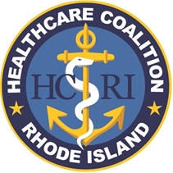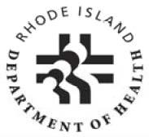RIDOH/HCRI
Once completed, send to:
- Dawn Lewis (dawnl@hari.org)
- Rupsha Biswas (rupsha.biswas@health.ri.gov)
Resource Request Form

Event:
Request Date/Time:
Requestor:
Primary Contact#:
Hospital:
Date/Time Needed:
Expected Delivery Location:
Request (be specific):

 | BELOW TO BE COMPLETED BY HEALTH
Request Assigned to: | Dawn Lewis (HCRI) and Alysia Mihalakos (RIDOH)
Action(s) taken (be specific):
Request Completed Date/Time: | Dawn Lewis 1/13/26
This is for HCRI requests only – All other requests should go through your local EMA Director

